**Student Name:- CHAUDHARY HAMDAN**

**Student Roll No.:- 1905387**

**Algorithm Lab. Class Assignment-10**

**CSE Group 1**

**Date: - 1st October 2021**

1. **Write a program to implementation of Fractional Knapsack algorithm.**

**Program**

// Author: Chaudhary Hamdan

// Generated: Fri Oct 1 12:22:06 2021

#include <stdio.h>

#include <time.h>

#include <stdlib.h>

#define sf(x) scanf("%d", &x)

#define pf printf

#define pfs(x) printf("%d ", x)

#define pfn(x) printf("%d\n", x)

#define pfc(x) printf("%d, ", x)

#define FI(i,x,y,inc) for(int i = x; i < y; i += inc)

#define F(i,x,y) FI(i, x, y, 1)

#define F0(i,n) FI(i, 0, n, 1)

#define RF(i,x,y) for(int i = x; i >= y; i--)

#define pfarr(i,a,n) for(int i = 0; i < n-1; i++) pfs(a[i]); pfn(a[n-1]);

void i_o_from_file();

int main() {

i_o_from_file();

/* ********************************************* */

int capacity, no_items, cur_weight, item;

int used[10];

float total_profit;

int i;

int weight[10];

int value[10];

sf(capacity);

sf(no_items);

F0(i, no_items) {

sf(weight[i]);

sf(value[i]);

}

F0(i, no_items) {

used[i] = 0;

}

cur_weight = capacity;

while (cur_weight > 0)

{

item = -1;

F0(i, no_items) {

if ((used[i] == 0) && ((item == -1) || (value[i] * 1.0 / weight[i] > value[item] * 1.0 / weight[item])))

item = i;

}

used[item] = 1;

cur_weight -= weight[item];

total_profit += value[item];

if (cur_weight >= 0) {

printf("Object %d completely\n", item + 1);

}

else {

int item_percent = (int) ((1 + cur_weight * 1.0 / weight[item]) * 100);

pf("Added %d%% of object %d.\n", item_percent, item + 1);

total_profit -= value[item];

total_profit += (1 + cur_weight * 1.0 / weight[item]) * value[item];

}

}

pf("\nFilled the bag with objects worth %.2f Rs.\n", total_profit);

return 0;

}

void i_o_from_file() {

#ifndef ONLINE_JUDGE

freopen("C:\\Users\\KIIT\\input", "r", stdin);

freopen("C:\\Users\\KIIT\\output", "w", stdout);

#endif

}

**Output**

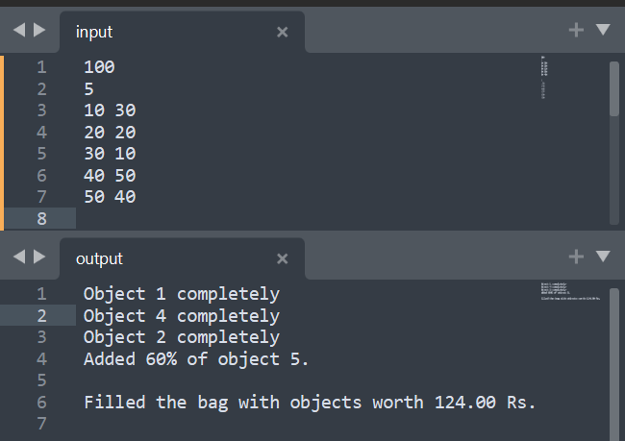

1. **Write a program to implement the activity-selection problem stated as follows:**

**You are given n activities with their start and finish times. Select the maximum number of activities that can be performed by a single person, assuming that a person can only work on a single activity at a time. Example: Consider the following 6 activities. start[] = {1, 3, 0, 5, 8, 5}; finish[] = {2, 4, 6, 7, 9, 9}; The maximum set of activities that can be executed by a single person is {0, 1, 3, 4}.**

**Program**

// Author: Chaudhary Hamdan

#include <stdio.h>

#include <time.h>

#include <stdlib.h>

#define sf(x) scanf("%d", &x)

#define pf printf

#define pfs(x) printf("%d ", x)

#define pfn(x) printf("%d\n", x)

#define pfc(x) printf("%d, ", x)

#define F(i,x,y) FI(i, x, y, 1)

#define F0(i,n) FI(i, 0, n, 1)

void i_o_from_file();

void activitySelection(int s[], int f[], int n)

{

int i, j;

pf("Activities selected:-\n");

i = 0;

pfs(i + 1);

for (j = 1; j < n; j++) {

if (s[j] >= f[i]) {

pfs(j + 1);

i = j;

}

}

}

int main() {

i_o_from_file();

/* ********************************************* */

int n;

sf(n);

int s[n], f[n];

F0(i, n) {

sf(s[i]);

sf(f[i]); // Giving input in sorted form wrt finish times.

}

time_t start, end;

double time;

start = clock();

activitySelection(s, f, n);

end = clock();

time = (end - start) * 1.0 / CLOCKS_PER_SEC;

pf("\nTime: %f\n", time);

return 0;

}

void i_o_from_file() {

#ifndef ONLINE_JUDGE

freopen("C:\\Users\\KIIT\\input", "r", stdin);

freopen("C:\\Users\\KIIT\\output", "w", stdout);

#endif

}

**Output**

